Contents

General notes 2

Wholesale and Retail Trade: 2

Transportation and Warehousing. 3

Professional, Scientific, and Technical Services 4

Business, Building and other Support Services 5

Educational Services 6

Health care and social assistance 7

Information, culture, and recreation 8

Accommodation and food services 9

Other services (excl. public admin) 10

Public Admin 11

# General notes

These were all generated with the same general approach as for the Service Industry topline numbers. The model was trained on data prior to the Jan 1, 2018 minimum wage increase, then forecast using the forecast’s own predictions to build the history of the model.

The theory is that the model cannot know about the minimum wage increase, and so its forecast is its best guess for the behaviour of the market without the minimum wage increase. Deviations from the forecast could be attributed to changes in industry hiring behaviours due to the increase in the minimum wage.

# Wholesale and Retail Trade:

The model expected the sharp spike in hiring in 2017 to continue roughly at that level, with seasonal ups and downs expected in retail (Holiday hirings, etc).

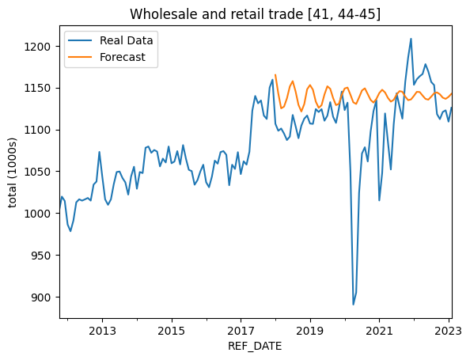

# Transportation and Warehousing.

This surged well beyond historical trends right after the minimum wage increase. The causes of this surge would require additional research, but clearly the increase in minimum wage to $14 in 2018 did nothing to cool this particular industry segment.

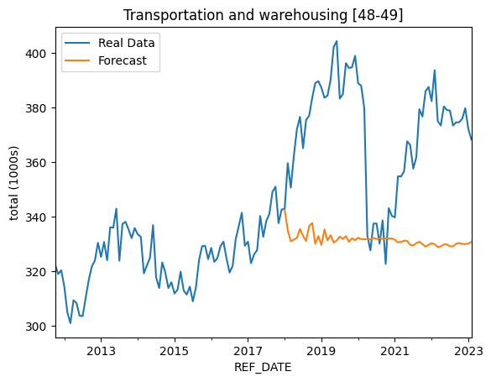

# Professional, Scientific, and Technical Services

The data here, while clearly having ups and downs, does not have a clean seasonality and the model seems to have struggled with that. Given that this industry is for skilled services, it would make sense that it is largely unaffected with changes to the minimum wage, as these services already pay much higher.

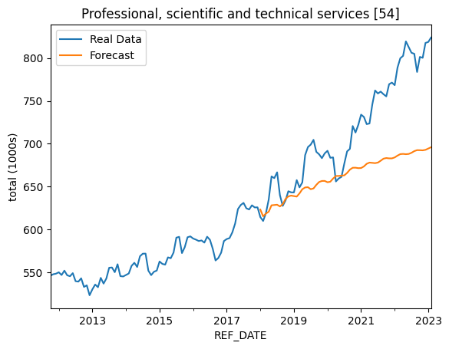

# Business, Building and other Support Services

This was on a slight downward trend prior to the minimum wage increase, and the model clearly expected slightly higher in the years prior to Covid hitting. This would suggest that these services were impacted by the minimum wage increase, but not by an enormous amount.

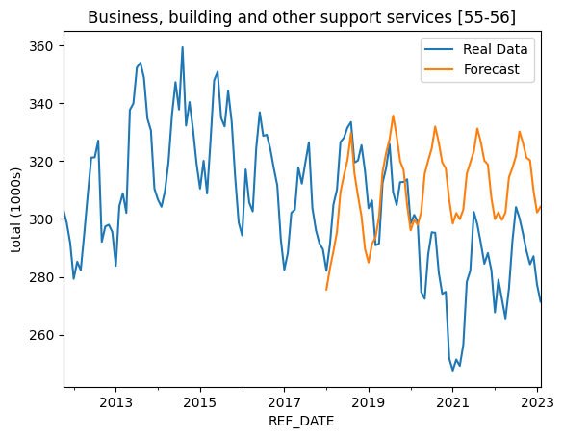

# Educational Services

Interestingly, Education services not only seem to have exceeded the forecast, suggesting the minimum wage increase did not impact hiring, but these services seem to have almost completely avoided the impact of Covid shutdown, except for the very earliest Covid months of 2020.

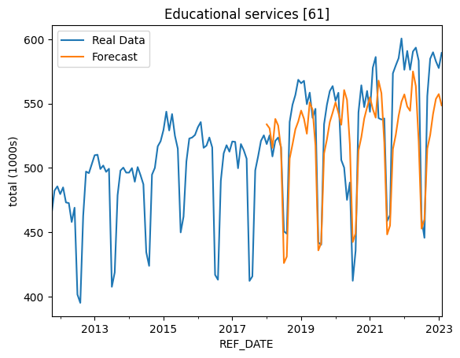

# Health care and social assistance

This is another where the forecast seems to have been exceeded by the real service performance over a few years, indicating that the minimum wage increase did not have much impact on the overall trend, though there is a clear trough immediately after the increase where the forecast was above reality, suggesting that the increase may have been depressed hiring temporarily in 2018 until the industry adjusted to the change in 2019.

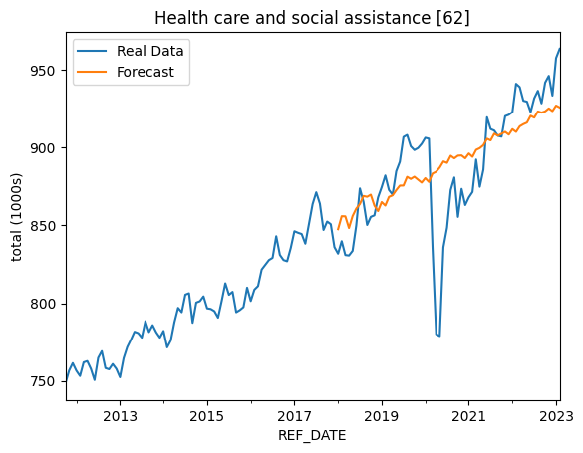

# Information, culture, and recreation

This service is highly seasonal, and its clear that the downward slopes on the seasonal employment rates drop off earlier and more sharply than the forecast. This would suggest that the minimum wage increase did impact the length of many temporary and seasonal contracts.

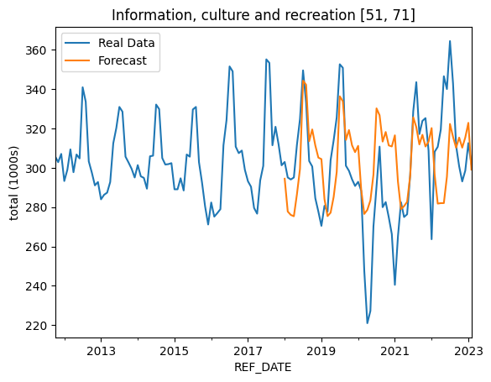

# Accommodation and food services

The forecast here had trouble with the non-seasonal ‘spikiness’ of this service industry segment. It does look like there was a small impact of the minimum wage increase, as the model did not expect the troughs to be as deep in 2018 or 2019.

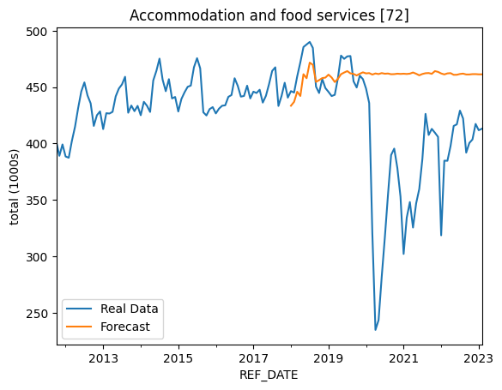

# Other services (excl. public admin)

The 2018 year closely matches the forecast, suggesting no real impact of the minimum wage increase. After 2018 the model is clearly struggling with forecasting on a longer timeline.

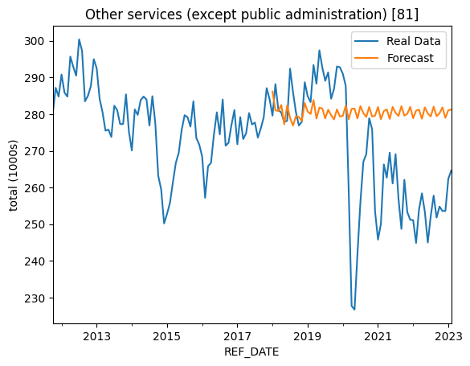

# Public Admin

This one is hard to categorize. The forecast is slightly higher than reality in 2018, suggesting a small impact, but then the surge in 2019, that continued through Covid, dwarfed any impact it may have had.

